**Proj2-2 Help**

**Part 2 Strategy**

# SPY vs IBM

One of the most common strategy for Mc2-p2 which I believe everyone would have tested will be checking correlation between SPY and IBM stocks i.e. we expect IBM to follow a similar trend of SPY.

**the instructors' answer,**

*where instructors collectively construct a single answer*

CAPM supports the idea.  If SPY and IBM have different bollinger values it is because of alpha.

sma trend strategy beats bollinger strategy

I have computed daily return on sma and used it to short and long the trades.  I mean, if the daily return is positive, long else short.  This strategy seems to work pretty well.

**the instructors' answer,**

*where instructors collectively construct a single answer*

I'm expecting 3 to 5 pages.  You can describe more strategies if you like, but be sure to

Elaboration on implementation suggestions

Well, for instance, if the market generally (say, SPY) is heading down in terms of its SMA right now, but IBM is heading up, then that's a very interesting thing -- the market overall is retreating, but IBM is racing ahead. Maybe you should choose to buy IBM even though the Bollinger Band indicator doesn't say you should.

https://piazza.com/class/idadrtx18nie1?cid=863

# Does the 'bollinger value" in suggestions means %b?

I searched it online and guess the bolingar value here means the following

%*b*=*price*−*lowerupper*−*lower*

This illustrate the position of the stock in the band (above upper line, in between, lower)

if %b_SPY and %b_IBM is very different, this might mean some signal?  I haven't clearly think it out.

[mc2-project-2](https://piazza.com/class/idadrtx18nie1?cid=863)

**~ An instructor (Tucker Balch) thinks this is a good question  ~**

**Part 1**

# Long/Short signals

Do we need to turn the datafram data, upper band, and lower band data into a function and find where they equal each other for the long and short signals? Or am I overthinking it?

**the instructors' answer,**

*where instructors collectively construct a single answer*

I would create an indicator value that ranges from -1 (at bottom band) to +1 (at top band) and then work on the trading signals from there.

# Plotting Bollinger Bands

On the .png provided, the upper and lower bands were clumped as just "Bollinger Bands". I can't plot a tuple of (upper,lower) and categorize it as Bollinger. So my question is, is it ok to just have

lower_band.plot(Label = "Upper Band", ax=ax,color = 'cyan')

upper_band.plot(Label= "Lower band", ax=ax,color = 'cyan')

*where students collectively construct a single answer*

If you name one "Bollinger Bands" and the other "" I think it gives you the desired effect

**~ An instructor (Tucker Balch) endorsed this answer  ~**

From scratch. Not too difficult if you use util.py, marketsim.py, maybe some code from analysis.py; model your code after preceding assignments.

**~ An instructor (Tucker Balch) endorsed this answer  ~**

# Bollinger Bands chart match, but diff cumulative return

My output bollinger band graph matches the one online identically, but my portfolio vs. spy is different. All the listed orders for first example matched mine originally, but I notice towards halfway and after my portfolio trends a bit different than the listed. Is there any way we could get access to a dummy 2 year range with the correct orders.csv so we could compare to make sure we are generating all the orders correctly?

[mc2-project-2](https://piazza.com/class/idadrtx18nie1?cid=788)

[**edit**](https://piazza.com/class/idadrtx18nie1?cid=788)·[good question](https://piazza.com/class/idadrtx18nie1?cid=788)0

Updated 1 day ago by Nick Anderson

**the students' answer,**

*where students collectively construct a single answer*

I believe it has to do with shorting later on...I don't think my marketsim.py handles shorting well since they weren't in test cases with previous project.

[**edit**](https://piazza.com/class/idadrtx18nie1?cid=788)·[thanks!](https://piazza.com/class/idadrtx18nie1?cid=788)0

Updated 1 day ago by Nick Anderson

**the instructors' answer,**

*where instructors collectively construct a single answer*

Let me suggest a *short* time period for testing so you can verify everything completely.  How about Dec 31 2007 to June 30, 2008?

**Plotting**

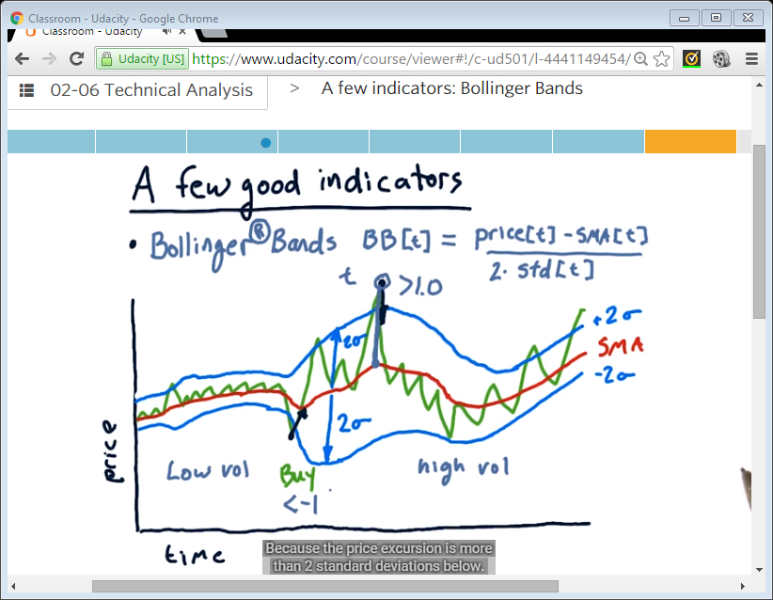

Do we have to trade 100 shares?

For Part 1, Bollinger, yes, it has to be 100 shares.  For Part 2 you can be more aggressive, but do not exceed 2.0 leverage.